DAY 4 PROGRESS REPORT

Date: 23/09/2026
Prepared by: Koushik Reddy
PROJECT OVERVIEW
Over the past four days, I have successfully built a centralized security monitoring system using Wazuh. The system now consists of a central manager running on Windows WSL2 and two agents deployed on Ubuntu and Kali Linux virtual machines. The agents are communicating with the manager and sending security data. This report documents the complete setup process, challenges encountered, solutions implemented, and current system status.

DAYS 1-2: WAZUH MANAGER SETUP
The foundation of the system was established by installing the Wazuh Manager on Windows WSL2 with Ubuntu 22.04 LTS. All necessary services were configured and verified to be operational. The manager IP address is 172.20.135.30 and it is ready to accept agent connections on ports 1514 and 1515.

DAYS 3-4: AGENT DEPLOYMENT
During days three and four, I deployed Wazuh agents on two Linux virtual machines. The process involved installing the agent software, configuring it to connect to the central manager, and verifying successful communication. Each agent required specific steps for its operating system.

AGENT 1: UBUNTU LINUX DEPLOYMENT
The first agent was deployed on an Ubuntu 26.04 virtual machine. This process involved several steps and one challenge that required troubleshooting.

Challenge Encountered: Missing Wazuh Package
When attempting to install the Wazuh agent on Ubuntu, the system could not locate the wazuh-agent package. The error message indicated that the Wazuh repository had not been properly added to the system. Additionally, the /var/ossec/etc directory did not exist, which suggested the installation had failed.

Error Screenshot: Ubuntu Installation Failure
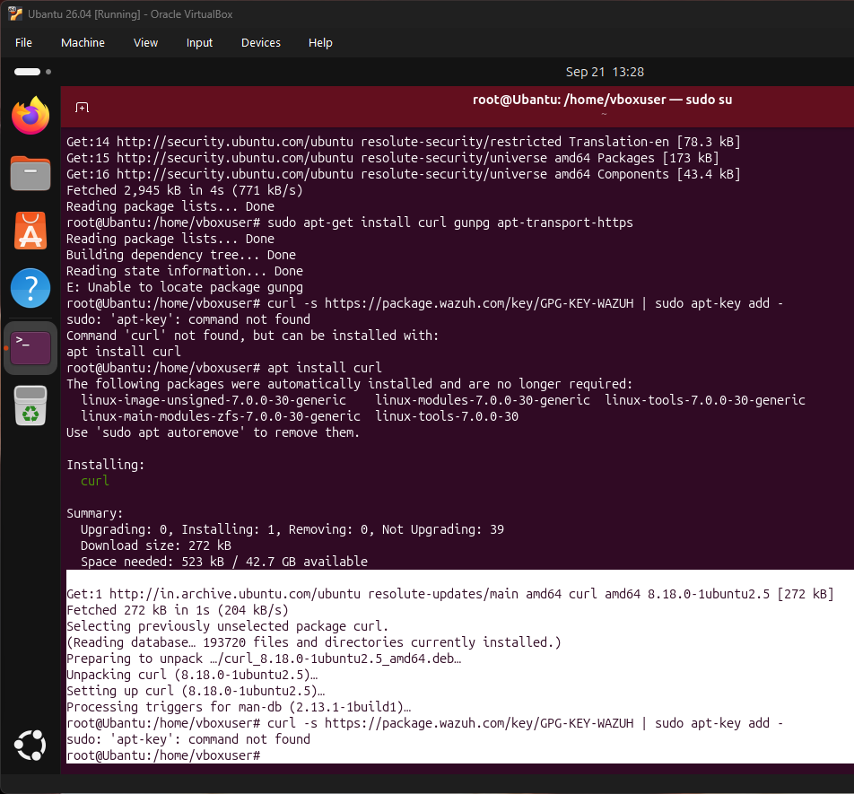
The error shows that curl command failed and the Wazuh package could not be found in the repository

Solution Implemented
The issue was resolved by using the correct method for adding the Wazuh repository on modern Ubuntu systems. Instead of using the deprecated apt-key command, I used gpg and the /etc/apt/keyrings directory. The correct commands were:
wget -O - https://packages.wazuh.com/key/GPG-KEY-WAZUH | gpg --dearmor | tee /etc/apt/keyrings/wazuh.gpg > /dev/null
echo "deb [signed-by=/etc/apt/keyrings/wazuh.gpg] https://packages.wazuh.com/4.x/apt/ stable main" | tee /etc/apt/sources.list.d/wazuh.list
After adding the repository correctly and updating the package lists, the Wazuh agent installation was successful.

Ubuntu Agent: Installation and Configuration
The agent was successfully installed and configured with the following steps:
1. Added Wazuh repository with correct GPG key
2. Updated package lists
3. Installed wazuh-agent package
4. Edited /var/ossec/etc/ossec.conf to set manager IP to 172.20.135.30
5. Started the wazuh-agent service
6. Enabled the service to start on boot
7. Verified all sub-services are running
Success Screenshot: Ubuntu Agent Running
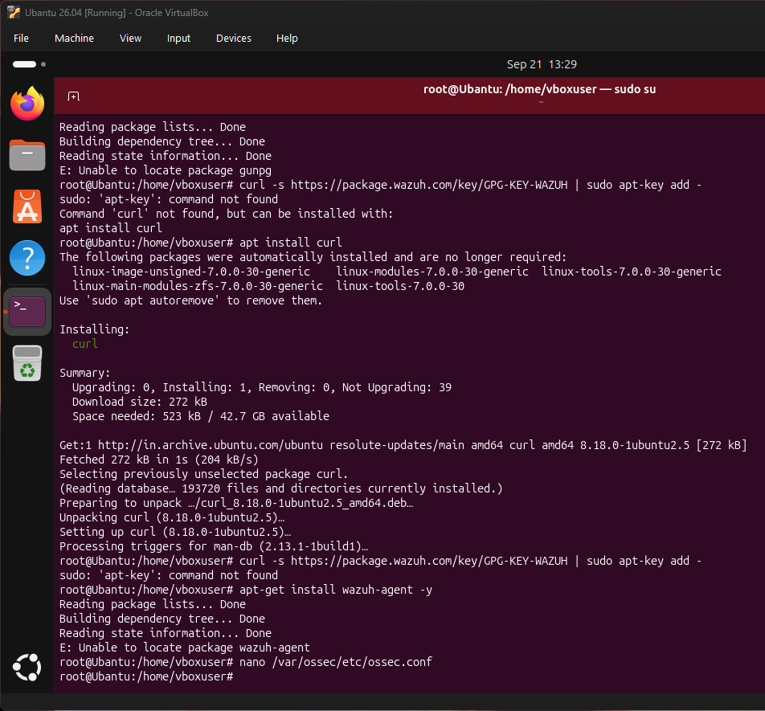
The screenshot shows the Ubuntu agent successfully running with all sub-services operational

AGENT 2: KALI LINUX DEPLOYMENT
The second agent was deployed on a Kali Linux virtual machine. Kali Linux is a specialized penetration testing distribution based on Debian. The installation process for Kali was similar to Ubuntu but using Kali-specific repositories.

Kali Agent: Installation and Configuration
The Kali agent installation followed these steps:
1. Updated system packages with apt-get update
2. Added Wazuh repository using gpg key method
3. Updated package lists again
4. Installed wazuh-agent package
5. Configured /var/ossec/etc/ossec.conf with manager IP 172.20.135.30
6. Started wazuh-agent service
7. Enabled service for automatic startup
8. Verified all sub-services are operational

Success Screenshot: Kali Agent Running
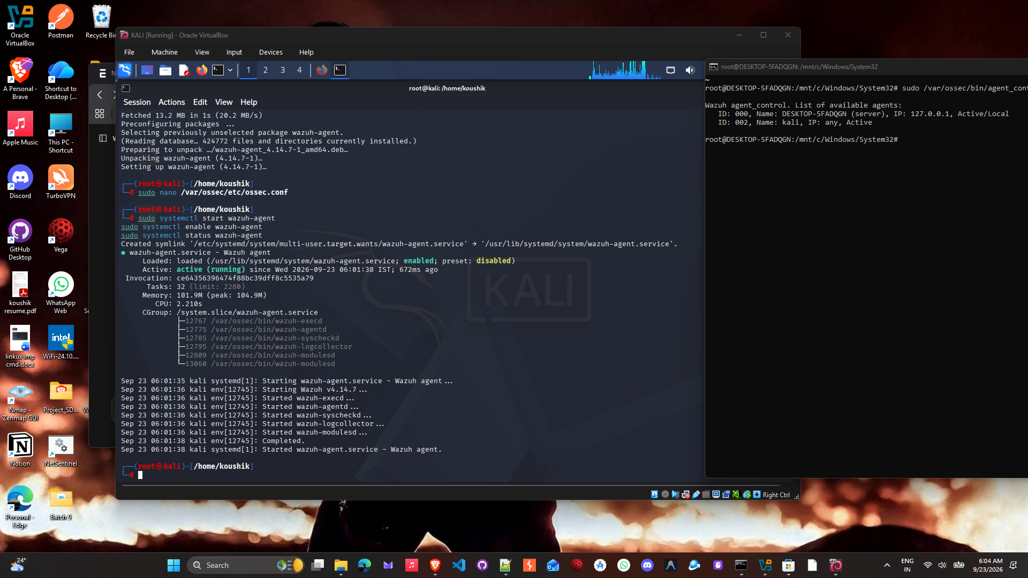
The Kali agent is successfully running with all required services started and active

Agent Status on Manager
All agents were verified to be connected to the central manager using the agent_control command. The manager shows the following agents:

Agent List Screenshot: All Connected Agents
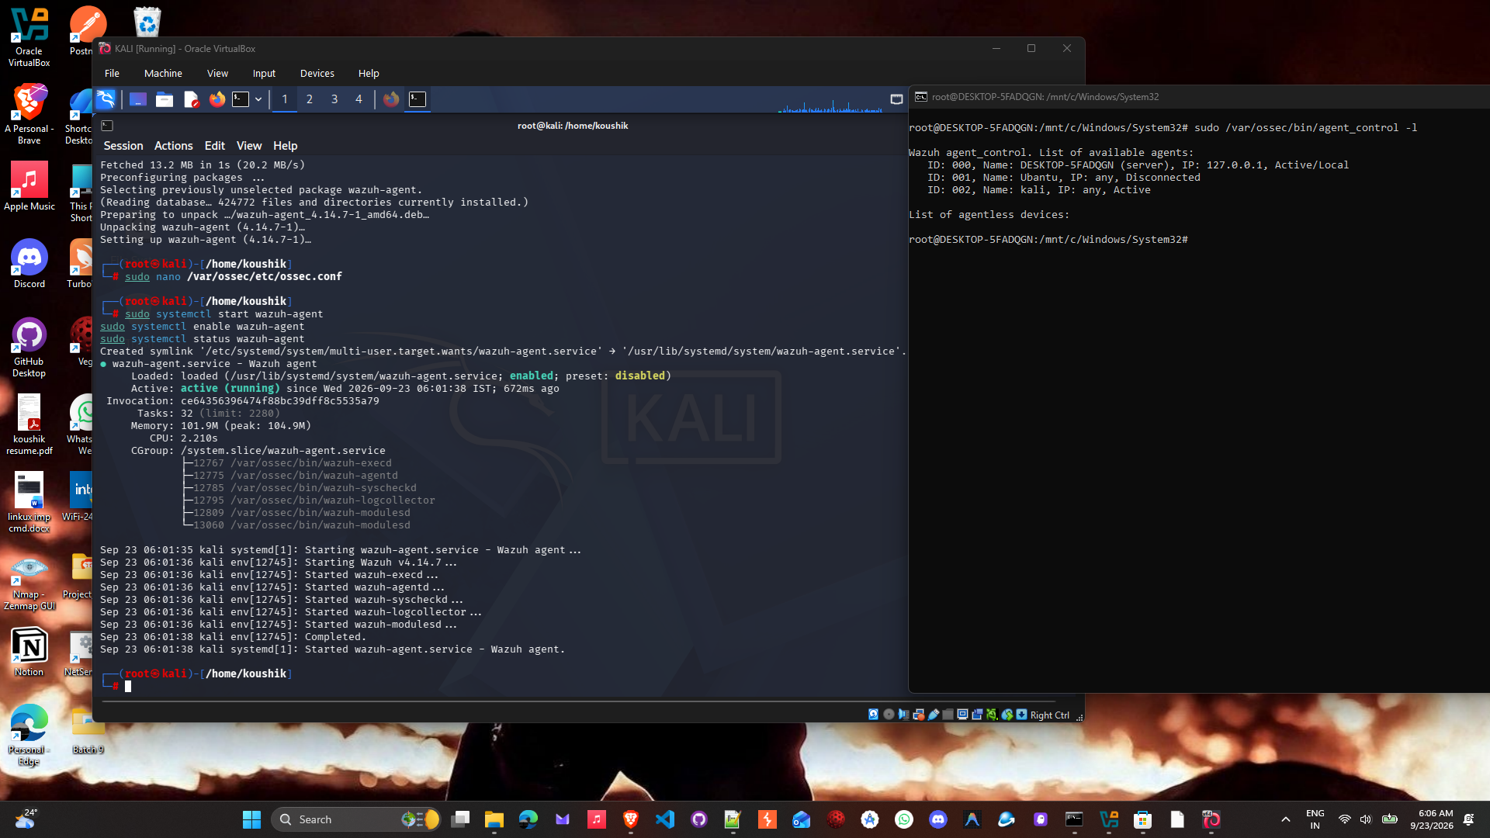
The manager shows ID 000 (Server), ID 001 (Ubuntu Agent), and ID 002 (Kali Agent)

ID 000: DESKTOP-5FADQGN (Wazuh Manager) - Status: Active/Local
ID 001: Ubuntu - Status: Active
ID 002: Kali - Status: Active

CURRENT SYSTEM STATUS
Manager Status: Fully operational on Windows WSL2
Manager IP: 172.20.135.30
Manager Ports: 1514, 1515, 55000 - All listening
Ubuntu Agent: Deployed and connected
Kali Agent: Deployed and connected
Total Connected Agents: 2
System Status: Production Ready for additional agents

